**VISVESVARAYA TECHNOLOGICAL UNIVERSITY,**

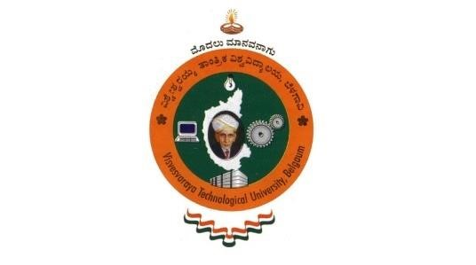**BELAGAVI-590018**

**A Mini- Project Report on**

**“PYTHON PROJECT FILE”**

**APPLICATION DEVELOPMENT USING PYTHON (18CS55)**

**(V SEMESTER)**

Submitted by

To the Visvesvaraya Technological University during the academic year 2022-2023 in partial

fulfilment for the award in the degree of

**BACHELOR OF ENGINEERING**

**in**

**COMPUTER SCIENCE AND ENGINEERING**

**Under the Guidance of**

**Mrs. SHASHIKALA M.K**

Assistant Professor,

Department of Computer Science & Engineering

Rajeev Institute of Technology

Hassan.

**RAJEEV INSTITUTE OF TECHNOLOGY**

**DEPARTMENT OF COMPUTER SCIENCE & ENGINEERING**

**HASSAN-573201,**

**2022-2023**